# Test Design Techniques

# Homework

## Valid vs. Invalid Values

* Imagine this year’s calendar (2013). We want to use it to schedule our business arrangement. Sort out the valid and invalid dates. Have in mind national holidays, weekends and the current date.

VALID

INVALID

7.09

31.11

17.07

14.12

24.10

5.05

9.08

27.10

21.1209

3.07

16.09

29.09

30.02

3.10

15.11

## Test Design Techniques

* Below is the diagram of test design techniques – fill in the names of the different techniques and match them with a sentence form the box to the left. (See the example)

**Testing**

**(2)**

**(7)**

**(5)**

**(6)**

**(8)**

**(9)**

**(3)**

**(4)**

**(1)**

**(11)**

**(10)**

1. Tests are based on people's skills, knowledge, intuition and experience
2. One of the types is Walkthrough
3. Also called specification-based
4. Structure-based techniques
5. Involve running (executing)
6. Analyzing software “at rest”
7. Tests are derived systematically from what is known about the defect
8. What the system does?
9. Examining running software to see how it behaves under different stimuli
10. How the system does what it does?
11. Do not involve running (executing)
12. Static - k
13. Dynamic
14. ___________
15. ___________
16. ___________
17. ___________
18. ___________
19. ___________
20. ___________
21. __________
22. __________

* **1. Static - k**
* **2. Dynamic**
* **3.___________**
* **4.___________**
* **5.___________**
* **6.___________**
* **7.___________**
* **8.___________**
* **9.___________**
* **10.__________**
* **11.__________**
* **1. Static - k**
* **2. Dynamic**
* **3.___________**
* **4.___________**
* **5.___________**
* **6.___________**
* **7.___________**
* **8.___________**
* **9.___________**
* **10.__________**
* **11.__________**
* **1. Static - k**
* **2. Dynamic**
* **3.___________**
* **4.___________**
* **5.___________**
* **6.___________**
* **7.___________**
* **8.___________**
* **9.___________**
* **10.__________**
* **11.__________**

\

## Boundary Value Analysis and Equivalence Partitioning

* Go to <http://demos.telerik.com/aspnet-ajax/input/examples/common/datagrid/defaultcs.aspx>
* 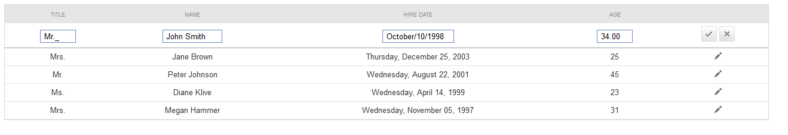
* Go to <http://demos.telerik.com/aspnet-ajax/input/examples/radinputmanager/validationthroughwebservice/defaultcs.aspx>

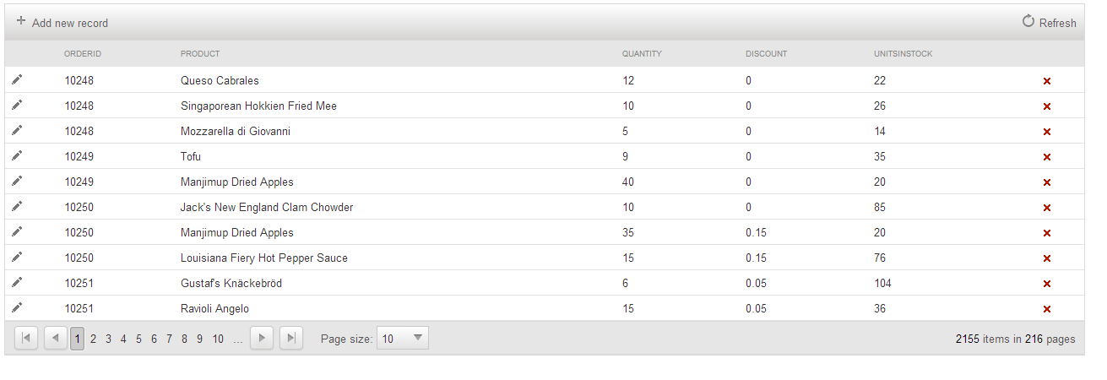

* Go to <http://demos.telerik.com/aspnet-ajax/combobox/examples/configurator/defaultcs.aspx>

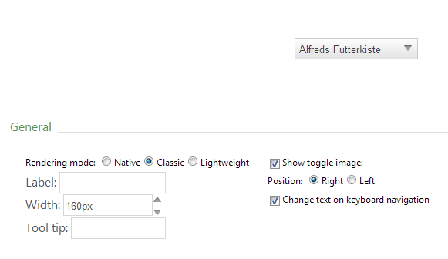

1. Think of appropriate test cases to test the controls and write them down in a table
2. Now chose the meaningful ones and create automated test cases using Test Studio Framework
3. If you find any bugs, please feel free to report them in a MS Word document